|  |  |
| --- | --- |
| **EX: 05** | **AREA CALCULATOR** |
| **22-08-2019** |

**Aim:**

To develop a java console application to perform area calculation using abstract classes.

**Requirement:**

Create an abstract class named Shape that contains two integers and an empty method named print

Area(). Three classes named Rectangle, Triangle and Circle such that each one of the classes

extends the class Shape. Each one of the classes contains only the method print Area () that prints

the area of the given shape.

**Algorithm:**

Step 1: Create class StringList with static main function in package stringcollection.

Step 2: Use switch case to perform necessary tasks.

Step 3: Use add() method to add a string.

Step 4: Use same add() method to add a string at particular index.

Step 5: Use indexOf() method to search for a string.

Step 6: Compare first letter of the strings from the list with the entered letter and display those

particular strings.

Step 7: Exit

**Class Diagram:**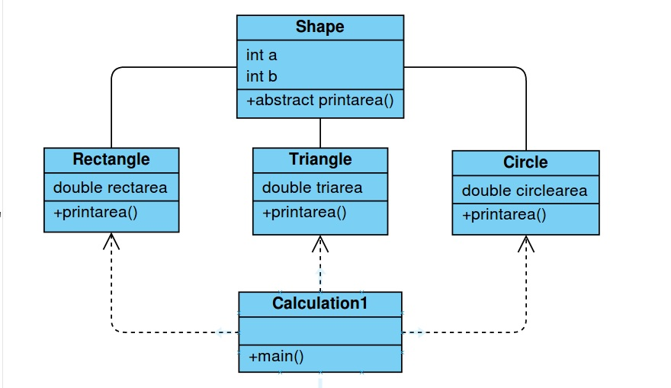

**Program:**

--------------------------------------------------AreaCalculator--------------------------------------------------------

………………………………………………………………Shapes………………………………………………………………………..

/*created by: Abhijith.S

* Gmail:abhijithabhi524@gmail.com

*/

package shapecollection;

public abstract class Shape {

int a,b;

public abstract void printArea();

}

…………………………………………….Rectangle……………………………………………

package shapecollection;

import java.util.Scanner;

public class Rectangle extends Shape{

double rectarea;

public void printArea() {

Scanner sc=new Scanner(System.in);

System.out.print("Enter the length and breadth of the

rectangle: \n");

a=sc.nextInt();

b=sc.nextInt();

rectarea=a*b;

System.out.printf("The length and the breadth of the

are"+a+" and "+b+" and its area is"+rectarea);

}

}

……………………………………………………Triangle………………………………………..

package shapecollection;

import java.util.Scanner;

public class Triangle extends Shape{

double triarea;

public void printArea() {

Scanner sc=new Scanner(System.in);

System.out.print("Enter the base and height of the

triangle: \n");

a=sc.nextInt();

b=sc.nextInt();

triarea=(0.5)*a*b;

System.out.printf("The height and the width of the

triangle are"+a+" and "+b+" and its area is

"+triarea);

}

}

……………………………………………….Circle……………………………………………….

/*created by: Abhijith.S

* Gmail:abhijithabhi524@gmail.com

*/

package shapecollection;

import java.util.Scanner;

public class Circle extends Shape{

double circlearea;

public void printArea() {

Scanner sc=new Scanner(System.in);

System.out.print("Enter the radius of the circle: \n");

a=sc.nextInt();

circlearea=(3.14)*a*a;

System.out.printf("The radius of the circle is "+a+" and

its area is "+circlearea);

}

}

………………………………………………….Calculation………………………………………

/*created by: Abhijith.S

* Gmail:abhijithabhi524@gmail.com

*/

package shapecollection;

import java.util.Scanner;

public class Calculation1 {

public static void main(String[] args) {

Rectangle r=new Rectangle();

Triangle t=new Triangle();

Circle c=new Circle();

int option;

Scanner sc=new Scanner(System.in);

while(true) {

System.out.println("\n Enter the shape of area you

want to calculate: ");

System.out.println("1.Rectangle");

System.out.println("2.Triangle");

System.out.println("3.Circle");

System.out.println("4.Exit");

option=sc.nextInt();

switch(option)

{ case 1:

r.printArea();

break;

case 2:

t.printArea();

break;

case 3:

c.printArea();

break;

case 4:

System.out.println("Thanks for using the

application!");

break;

default:

System.out.println("Enter a valid option!!");

} if(option==4)

break;

}

}

}

**Output:**

Enter the shape of area you want to calculate:

1.Rectangle

2.Triangle

3.Circle

4.Exit

1 Enter the length and breadth of the rectangle:

45 The length and the breadth of the rectangle are4 and 5

and its area is 20.0

Enter the shape of area you want to calculate:

1.Rectangle

2.Triangle

3.Circle

4.Exit

2 Enter the base and height of the triangle:

45 The height and the width of the triangle are4 and 5

and its area is 10.0

Enter the shape of area you want to calculate:

1.Rectangle

2.Triangle

3.Circle

4.Exit

3 Enter the radius of the circle:

1 The radius of the circle is 1

and its area is 3.14

Enter the shape of area you want to calculate:

1.Rectangle

2.Triangle

3.Circle

4.Exit

4 Thanks for using the application!

**Result:**

Thus the java application for area calculation is executed and the

output is verified succesfully.